Kafka-Pyspark Structured Streaming

1.Introduction
Modern data-driven systems generate massive amounts of information every second. In domains such as industrial monitoring, defense systems, IoT environments, and sensor networks, data is continuously produced by multiple sources and must be processed in real time. Traditional batch-processing approaches are often insufficient for handling these continuous streams of data, creating the need for scalable real-time data processing architectures.
The DataForge project aims to build a real-time data processing platform capable of collecting, transporting, processing, and analyzing sensor and telemetry data. To achieve this goal, the platform utilizes Apache Kafka and PySpark Structured Streaming as its core streaming technologies. Kafka provides a reliable and scalable messaging layer for transporting data between system components, while PySpark Structured Streaming enables real-time processing, filtering, aggregation, and transformation of incoming data streams.
This document summarizes the key concepts learned about Apache Kafka and PySpark Structured Streaming and explains their role within the DataForge architecture. Particular attention is given to Kafka consumer groups, Spark watermarks, stream-stream joins, and real-time data processing workflows, as these concepts are essential for building scalable and reliable streaming applications.
The document also demonstrates how Kafka and Spark work together to create an end-to-end data pipeline. Through practical examples and architectural explanations, it provides an understanding of how real-time sensor data can be collected, processed, fused, and prepared for downstream analytics and AI-based decision-making systems.
The objective of these learning notes is to establish a solid foundation for future implementation tasks within DataForge, where Kafka and PySpark Structured Streaming will be used to support real-time data ingestion, data fusion, and intelligent analytics.

2.Apache Kafka Fundamentals

2.1.About Apache Kafka
Apache Kafka is an open-source distributed event streaming platform designed to handle large volumes of real-time data. It was originally developed by LinkedIn and later became an Apache Software Foundation project. Today, Kafka is widely used by organizations that need to collect, transport, and process continuous streams of data in a reliable and scalable manner.
At its core, Kafka acts as a central communication layer between systems that produce data and systems that consume data. Instead of sending information directly from one application to another, data is first published to Kafka and then made available to any authorized consumer. This decouples producers and consumers, making the overall architecture more flexible and easier to scale.
Kafka is built around the concept of events. An event represents a piece of information that has occurred at a specific point in time. Examples of events include a radar detection, a GPS position update, a temperature measurement, or a telemetry status message. These events are continuously published to Kafka and stored within topics, allowing other systems to process them in real time.
One of Kafka’s key advantages is its ability to handle high-throughput data streams while maintaining reliability and fault tolerance. Kafka can process millions of events per second across multiple servers and can continue operating even if individual components fail. This makes it particularly suitable for real-time systems where continuous data availability is essential.
Within the DataForge project, Apache Kafka serves as the primary data transportation layer. Sensor and telemetry data generated by various sources are first published to Kafka topics before being processed by PySpark Structured Streaming. Kafka therefore acts as the backbone of the real-time data pipeline, ensuring that information can be collected, stored temporarily, and delivered efficiently to downstream processing systems.
A simplified view of Kafka within DataForge is shown below:
Radar Sensor
GPS Sensor
Telemetry Sensor
Temperature Sensor
│
▼
Apache Kafka
│
▼
PySpark Structured Streaming
│
▼
AI Models and Analytics
In this architecture, Kafka is responsible for reliably transporting real-time sensor data, while downstream components focus on processing, analysis, and decision-making.

2.2.Kafka Architecture
Apache Kafka follows a distributed architecture designed to support high-throughput, fault-tolerant, and scalable real-time data processing. Rather than operating as a single server, Kafka is typically deployed as a cluster consisting of multiple components that work together to store, manage, and distribute data streams.
The main architectural components of Kafka are Brokers, Topics, Partitions, Producers, and Consumers. Each component plays a specific role within the data pipeline.

2.2.1.Kafka Broker
A Kafka Broker is a server responsible for receiving, storing, and serving data. A Kafka deployment may consist of one or many brokers working together as a cluster.
When a producer sends a message, the broker receives and stores it. Consumers later retrieve these messages from the broker.
Producer
│
▼
Kafka Broker
│
▼
Consumer
Using multiple brokers improves scalability and fault tolerance. If one broker becomes unavailable, other brokers can continue serving data.

2.2.2.Kafka Topics
A topic is a logical channel used to organize messages within Kafka. Producers write messages to topics, and consumers read messages from topics.
For example, a DataForge deployment may use separate topics for different sensor sources:
- radar-topic
- gps-topic
- telemetry-topic
- temperature-topic
This separation allows different data streams to be processed independently while remaining part of the same Kafka infrastructure.

2.2.3.Kafka Partitions
Topics can be divided into multiple partitions.
Partitions allow Kafka to distribute data across multiple servers and enable parallel processing.
Example:
radar-topic
Partition 0
Partition 1
Partition 2
Partition 3
When new messages arrive, Kafka distributes them across the available partitions.
Because partitions can be processed independently, multiple consumers can work simultaneously, significantly increasing throughput.

2.2.4.Kafka Producers
A producer is an application or service that sends data to Kafka.
Within DataForge, producers may include:
- Radar systems
- GPS devices
- Telemetry systems
- Environmental sensors
- Data simulation tools
Example:
Radar Sensor
│
▼
Kafka Producer
│
▼
radar-topic
The producer is responsible for publishing events to the appropriate Kafka topic.

2.2.5.Kafka Consumers
A consumer is an application that reads data from Kafka topics.
In the DataForge architecture, PySpark Structured Streaming acts as a consumer.
Example:
radar-topic
│
▼
Spark Consumer
│
▼
Processing Engine
Consumers continuously monitor topics and process new events as they arrive.

2.3.Kafka Architecture in DataForge
A simplified Kafka architecture for DataForge can be represented as follows:
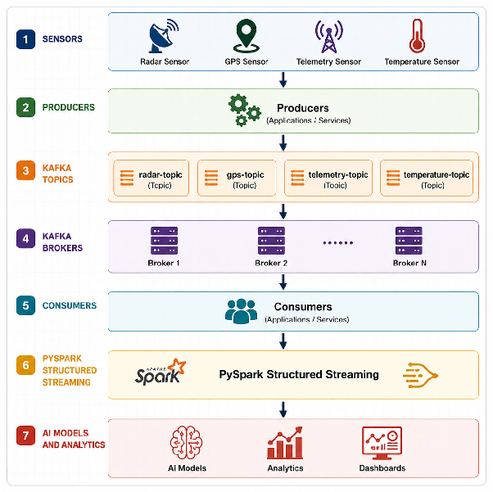
This architecture enables DataForge to collect large volumes of sensor data, transport them reliably through Kafka, and deliver them to Spark for real-time processing and analysis.

2.4.Consumer Groups and Their Importance for DataForge
One of the most important scalability features provided by Apache Kafka is the concept of consumer groups. A consumer group is a collection of consumers that work together to process data from one or more Kafka topics. Instead of a single consumer reading all incoming messages, Kafka can distribute the workload across multiple consumers, allowing data to be processed in parallel.
When a topic contains multiple partitions, Kafka automatically assigns partitions to consumers within the same group. Each partition is consumed by only one consumer within the group, ensuring that messages are processed efficiently without duplication.
A simplified example is shown below:
radar-topic
Partition 0 → Consumer 1
Partition 1 → Consumer 2
Partition 2 → Consumer 3
Partition 3 → Consumer 4
In this example, four consumers share the workload of processing messages from the same topic. Because the work is distributed across multiple consumers, the system can handle a much higher volume of incoming data than a single consumer could process alone.
Consumer groups provide several important advantages:
Scalability
As data volumes increase, additional consumers can be added to the group. Kafka automatically redistributes partitions among available consumers, allowing the system to scale horizontally.
Fault Tolerance
If a consumer fails, Kafka automatically reassigns its partitions to the remaining consumers in the group. This helps maintain continuous operation and reduces the risk of data processing interruptions.
Higher Throughput
Multiple consumers can process messages simultaneously, significantly increasing the number of events that can be handled per second.
Load Balancing
Kafka distributes partitions evenly across consumers whenever possible, ensuring that processing workloads are balanced throughout the system.
Why Consumer Groups Matter for DataForge
DataForge is designed to process real-time sensor and telemetry streams generated by multiple sources, including radar systems, GPS devices, and other environmental sensors. These sources may continuously produce large volumes of data that must be processed with low latency.
Without consumer groups, a single Spark consumer would be responsible for processing all incoming events. As data volumes increase, this could create a bottleneck and limit system performance.
By using consumer groups, DataForge can distribute Kafka partitions across multiple Spark workers. This allows the platform to process larger data streams, maintain real-time responsiveness, and support future scaling requirements.
A simplified DataForge example is shown below:
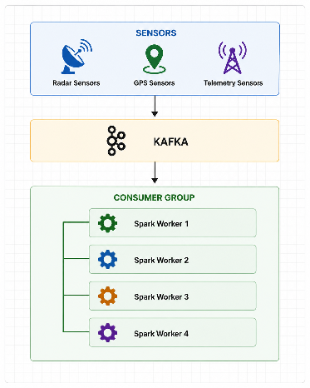
In this architecture, multiple Spark workers cooperate to process incoming sensor data. As the volume of data grows, additional workers can be added to the consumer group, allowing DataForge to maintain high throughput and reliable real-time processing.
For these reasons, consumer groups are a critical component of the DataForge architecture and play a key role in achieving scalability, reliability, and efficient real-time data processing.

3.Pyspark Structured Streaming Fundamentals {#3.pyspark-structured-streaming-fundamentals}

3.1.About Pyspark Structured Streaming {#3.1.about-pyspark-structured-streaming}
PySpark Structured Streaming is Apache Spark's scalable stream processing engine designed for handling continuous real-time data streams. It allows developers to process data as it arrives rather than waiting for large batches of data to be collected first. This capability makes Structured Streaming particularly useful for applications that require low-latency analytics, real-time monitoring, and continuous event processing.
Unlike traditional batch processing systems, which operate on static datasets, Structured Streaming treats incoming data as an unbounded table that continuously grows over time. As new records arrive, Spark automatically processes them and updates the results in near real time.
Within the DataForge project, PySpark Structured Streaming serves as the primary processing layer of the architecture. While Apache Kafka is responsible for transporting and storing incoming sensor events, Spark is responsible for transforming those events into meaningful information.
A simplified view of the relationship between Kafka and Spark is shown below:
Sensor Data
│
▼
Apache Kafka
│
▼
PySpark Structured Streaming
│
▼
Processed Information
PySpark Structured Streaming can perform a variety of real-time operations, including:
- Reading live data streams from Kafka topics.
- Filtering invalid or unnecessary events.
- Applying schema validation.
- Performing aggregations and calculations.
- Managing delayed events using watermarks.
- Joining multiple streams for data fusion.
- Producing outputs for dashboards, analytics platforms, and AI models.
For example, consider a radar sensor continuously sending target information:
{
"target_id": "A12",
"speed": 120,
"distance": 1400
}
When this event arrives in Kafka, Spark can immediately consume it and perform processing operations such as filtering, aggregation, or feature extraction. Instead of waiting for thousands of records to accumulate, Spark processes the event as part of a continuous stream.
One of the most important advantages of Structured Streaming is that it provides a high-level DataFrame API similar to traditional Spark applications. This means developers can use familiar Spark operations while still benefiting from real-time stream processing capabilities.
Within DataForge, Structured Streaming enables the platform to transform raw sensor data into actionable information. It acts as the bridge between data ingestion and intelligent analytics, ensuring that incoming events can be processed efficiently and delivered to downstream systems with minimal latency.
As a result, PySpark Structured Streaming plays a central role in achieving the DataForge goal of reliable real-time data processing, sensor fusion, and AI-driven decision making.

3.2.Spark Structured Streaming Architecture
PySpark Structured Streaming follows a layered architecture that enables continuous processing of real-time data streams. The architecture is designed to ingest data from external sources, process it using Spark's distributed computing engine, and deliver the results to downstream systems with low latency.
Within the DataForge project, Spark Structured Streaming acts as the central processing engine between Apache Kafka and the analytics layer. Incoming sensor events are consumed from Kafka, transformed into structured data, processed through various operations, and finally delivered to AI models, dashboards, or analytics systems.
A simplified Spark Structured Streaming architecture is shown below:
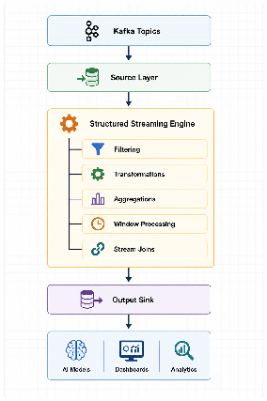

3.2.1.Source Layer
The source layer is responsible for receiving incoming data streams. Spark supports multiple streaming sources, including Apache Kafka, files, sockets, and cloud-based storage systems.
In DataForge, Apache Kafka serves as the primary streaming source. Sensor and telemetry data are continuously published to Kafka topics and consumed by Spark in real time.

3.2.2.Structured Streaming Engine
The Structured Streaming Engine is the core processing component of Spark. It continuously monitors incoming data streams and applies transformations as new records arrive.
Unlike traditional batch processing systems, Spark processes streaming data using a micro-batch model. Incoming events are grouped into very small batches and processed continuously, creating the appearance of real-time processing.
For example:
Time 00:00 → Batch 1
Time 00:01 → Batch 2
Time 00:02 → Batch 3
Time 00:03 → Batch 4
Each batch may contain hundreds or thousands of sensor events depending on the incoming data rate.

3.2.3.Processing Operators
After data enters the Structured Streaming Engine, Spark can perform a variety of processing operations.
Common operations include:
- Filtering unwanted events
- Schema validation
- Data transformation
- Aggregation
- Window-based calculations
- Stream-stream joins
- Feature extraction
These operations allow raw sensor data to be transformed into meaningful information suitable for analytics and machine learning applications.

3.2.4.Output Sink
Once processing is complete, Spark writes the results to an output destination known as a sink.
Examples include:
- Console output
- Databases
- Data lakes
- Dashboard systems
- AI and machine learning pipelines
Within DataForge, processed data will primarily be delivered to analytics systems and AI models for further analysis and decision-making.

3.3.Spark Architecture in DataForge
A simplified DataForge processing pipeline can be represented as follows:
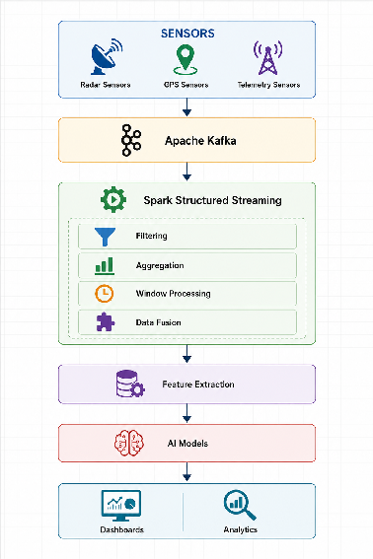
This architecture enables DataForge to process large volumes of sensor data efficiently while maintaining low latency and supporting real-time analytics. By separating data ingestion, processing, and output layers, Spark Structured Streaming provides a scalable foundation for future DataForge implementations.

3.4.Reading Data From Kafka
One of the primary responsibilities of PySpark Structured Streaming within the DataForge architecture is consuming real-time data streams from Apache Kafka. After sensors and telemetry systems publish events to Kafka topics, Spark continuously listens for new messages and processes them as they arrive.
This capability enables DataForge to perform real-time analytics without waiting for large batches of data to accumulate. As soon as a new event is published to Kafka, Spark can consume it and begin processing.
The process of reading data from Kafka consists of several steps:
- Establishing a connection to the Kafka cluster.
- Subscribing to one or more Kafka topics.
- Receiving incoming messages.
- Converting raw Kafka records into structured data.
- Passing the data to downstream processing operations.
A simplified data flow is shown below:
Sensor Event
│
▼
Kafka Topic
│
▼
Spark Consumer
│
▼
Structured Data
Creating a Spark Streaming Session
Before Spark can consume data from Kafka, a Spark session must be created.
Example:
from pyspark.sql import SparkSession
spark = SparkSession.builder \
.appName("DataForgeStreaming") \\
.getOrCreate()
The Spark session acts as the entry point for all Structured Streaming operations.
Connecting to Kafka
Once the Spark session is available, Spark can subscribe to Kafka topics.
Example:
kafka_stream = spark.readStream \
.format("kafka") \\
.option("kafka.bootstrap.servers", "localhost:9092") \\
.option("subscribe", "radar-topic") \\
.load()
This configuration tells Spark:
- Use Kafka as the streaming source.
- Connect to the Kafka broker running on port 9092.
- Subscribe to the topic named radar-topic.
- Continuously listen for new incoming events.
Understanding Kafka Records
When Spark reads data from Kafka, the messages are not immediately available as structured columns.
Instead, Spark receives metadata and raw message contents.
Example:
- key
- value
- topic
- partition
- offset
- timestamp
The actual sensor information is typically stored inside the value column.
For example:
{
"target_id": "A12",
"speed": 120,
"distance": 1400
}
Converting Kafka Data into Structured Format
Because Kafka messages are often stored as JSON, Spark must parse them before further processing can occur.
Example:
from pyspark.sql.functions import col
events = kafka_stream.selectExpr(
"CAST(value AS STRING)"
)
This converts the raw Kafka message into a readable string representation.
Later sections will show how Spark can parse the JSON structure and convert it into individual columns.
Reading Data in DataForge
Within DataForge, Spark will continuously consume sensor events from Kafka topics such as:
- radar-topic
- gps-topic
- telemetry-topic
Each incoming event becomes available for processing immediately after it arrives.
This allows DataForge to:
- Monitor sensor activity in real time.
- Process telemetry streams continuously.
- Support low-latency analytics.
- Feed AI models with fresh information.
- Perform data fusion across multiple streams.
As a result, reading data from Kafka represents the first processing step performed by PySpark Structured Streaming and serves as the foundation for all subsequent operations such as filtering, aggregation, watermarking, and stream-stream joins.

3.5.Event Filtering {#3.5.event-filtering}
After consuming data from Kafka, one of the first operations performed by PySpark Structured Streaming is event filtering. Filtering allows Spark to select only the records that are relevant for further processing while ignoring unnecessary, invalid, or low-priority events.
In real-world streaming systems, not every incoming event is useful. Sensors may occasionally produce corrupted data, missing values, duplicate records, or events that do not meet business requirements. Processing such records would consume unnecessary resources and potentially reduce the accuracy of downstream analytics.
For this reason, filtering is commonly used as an early stage in a streaming pipeline.
Why is Filtering important?
Filtering provides several benefits:
- Removes invalid records.
- Reduces processing overhead.
- Improves data quality.
- Increases analytical accuracy.
- Prevents unnecessary computations.
By filtering unwanted records as early as possible, Spark can focus its resources on processing meaningful events.
Simple Filtering Examples
Assume that DataForge receives the following events:
Event A → Priority 2
Event B → Priority 8
Event C → Priority 4
Event D → Priority 9
If the system is configured to process only high-priority events, a filtering condition can be applied:
priority >= 5
Result:
Event B
Event D
Only the events that satisfy the condition continue through the processing pipeline.
Filtering in Pyspark Structured Streaming
PySpark provides the filter() function for selecting specific records.
Example:
filtered_events = events.filter(
col("priority") \>= 5
)
In this example, Spark only processes events whose priority value is greater than or equal to five.
Data Quality Filtering
Filtering is also useful for removing invalid sensor readings.
Example:
valid_events = events.filter(
(col("speed") \>= 0\) &
(col("distance") \>= 0\)
)
This rule removes records containing impossible values such as negative speed or negative distance measurements.
For example:
Target A → Speed = 120
Target B → Speed = -35
Target C → Speed = 90
After filtering:
Target A → Speed = 120
Target C → Speed = 90
The invalid record is discarded.
Filtering in DataForge
Within DataForge, filtering may be applied to:
- Invalid sensor readings.
- Corrupted telemetry messages.
- Missing values.
- Low-priority events.
- Out-of-range measurements.
Example:
Radar Event
Speed = -20
Such a record would likely be rejected before entering later processing stages.

3.6.Position of Filtering in the DataForge Pipeline
Filtering is one of the earliest processing steps within the Spark pipeline:
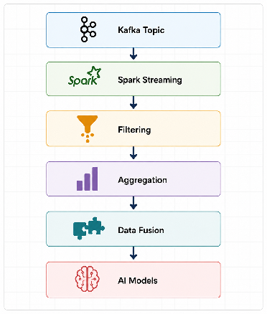

3.7.Window Processing
In real-time streaming systems, processing every event individually is often inefficient and may not provide meaningful insights. Instead, events are commonly grouped into fixed periods of time known as windows. Window processing allows Spark Structured Streaming to collect events that occur within a specified time interval and perform calculations on them as a group.
This approach is particularly useful when analyzing trends, averages, counts, or other statistical measurements over time. Rather than examining each sensor event separately, Spark can summarize information across a window of events and generate more meaningful results.
Why is Window Processing important?
Window processing provides several advantages:
- Reduces the complexity of analyzing individual events.
- Enables real-time statistical calculations.
- Supports trend detection and monitoring.
- Produces aggregated features for AI models.
- Improves the efficiency of stream processing pipelines.
Without windows, Spark would treat every event independently. While this is possible, many analytics tasks require information about groups of events rather than single records.
Example of Window Processing
Assume a radar sensor generates the following speed measurements:
10:00:01 → 100 km/h
10:00:05 → 120 km/h
10:00:10 → 130 km/h
10:00:15 → 110 km/h
Instead of processing these values individually, Spark can group them into a 30-second window and calculate summary statistics.
Result:
Average Speed = 115 km/h
Maximum Speed = 130 km/h
Minimum Speed = 100 km/h
This provides a much clearer picture of sensor activity during that time period.
Window Processing in PySpark
Spark provides a built-in window function for grouping events by time.
Example:
from pyspark.sql.functions import window
windowed_data = events.groupBy(
window("event_time", "30 seconds")
)
In this example, Spark groups all events that occur within each 30-second interval.
Types of Windows
Structured Streaming supports several window types.
Tumbling Windows
A tumbling window consists of fixed, non-overlapping time intervals.
Example:
00:00 - 00:30
00:30 - 01:00
01:00 - 01:30
Each event belongs to exactly one window.
Sliding Windows
Sliding windows overlap and allow events to participate in multiple windows.
Example:
Window Size: 30 seconds
Slide Interval: 10 seconds
Result:
00:00 - 00:30
00:10 - 00:40
00:20 - 00:50
This provides smoother and more continuous analytics.

3.8.Window Processing in DataForge
Within DataForge, window processing can be used to summarize sensor activity over short time periods.
Examples include:
- Average target speed over the last 30 seconds.
- Number of radar detections per minute.
- Average telemetry values over time.
- Sensor activity rates.
- Aggregated features for machine learning models.
A simplified DataForge example is shown below:
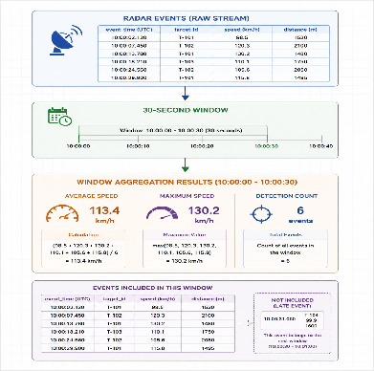
Instead of sending every raw event directly to AI models, Spark can first calculate meaningful summaries. These summaries become features that are easier for analytics systems and machine learning models to interpret.
Window Processing and Data Fusion
Window processing also plays an important role in Data Fusion. Since sensor events often arrive at different times, grouping them into common time windows allows Spark to compare and combine information from multiple streams more effectively.
This capability becomes even more important when handling delayed events, which leads directly to the concept of watermarks discussed in the next section.

3.9.Watermarks and Their Importance for DataForge
In real-time streaming systems, events do not always arrive in the exact order in which they were generated. Network latency, transmission delays, temporary outages, and processing bottlenecks can cause some events to arrive later than expected. These delayed records are commonly referred to as late events.
Without a mechanism for handling late events, stream processing systems may produce incomplete or inaccurate results. To solve this problem, Spark Structured Streaming provides a feature known as a watermark.
A watermark defines how long Spark should wait for delayed events before considering a window complete and finalizing its results. In other words, a watermark allows Spark to tolerate a certain amount of lateness while still maintaining efficient real-time processing.
Event Time vs Processing Time
To understand watermarks, it is important to distinguish between two different timestamps.
Event Time
Event time represents when an event actually occurred.
Example:
Radar Detection Created:
12:00:01.200
Processing Time
Processing time represents when Spark receives and processes the event.
Example:
Radar Detection Processed:
12:00:01.450
In an ideal system, these times would be identical. However, in real-world environments, delays are common.
Example of a Late Event
Consider the following sensor events:
12:00:01 Radar Event
12:00:02 GPS Event
12:00:03 Telemetry Event
Suppose another radar event was generated at:
12:00:02.500
but due to network latency, it arrives at Spark at:
12:00:04.100
This event is considered late because it arrives after newer events have already been processed.
Without a watermark, Spark may discard the delayed record or produce incorrect aggregations.
Using Watermarks in Spark
Spark allows developers to define an acceptable delay threshold.
Example:
.withWatermark(
"event\_time",
"500 milliseconds"
)
This configuration tells Spark:
Continue accepting events that arrive up to 500 milliseconds late.
Events arriving after that threshold may be ignored in order to maintain system performance and avoid keeping windows open indefinitely.
Why Watermarks are Important
Watermarks provide several benefits:
- Handle delayed events correctly.
- Improve aggregation accuracy.
- Support reliable stream-stream joins.
- Reduce data loss.
- Prevent windows from remaining open forever.
- Maintain predictable system latency.
Without watermarks, real-time analytics systems would struggle to produce accurate results when events arrive out of order.
Why DataForge Uses Watermarks
DataForge combines information from multiple sensor sources, including:
- Radar Sensors
- GPS Sensors
- Telemetry Systems
- Environmental Sensors
These sources may operate at different speeds and may experience different network conditions.
For example:
Radar Event arrives immediately.
GPS Event arrives 300 ms later.
Telemetry Event arrives 450 ms later.
Even though all three events describe the same situation, they do not reach Spark at exactly the same moment.
If Spark processes the data too quickly, some events may be excluded from aggregations or data fusion operations.
By introducing a watermark, Spark can briefly wait for delayed events and produce more accurate results.
DataForge Watermark Target: 500 ms
The current DataForge design targets a watermark value of:
500 milliseconds
This value represents a balance between:
- Accuracy
- Latency
- Resource usage
A larger watermark would allow more delayed events to be included but would increase overall system latency.
A smaller watermark would reduce latency but increase the risk of excluding legitimate delayed events.
For DataForge, a 500 ms watermark provides sufficient tolerance for typical sensor transmission delays while still supporting near real-time processing.
Watermarks and Data Fusion
Watermarks become even more important when performing stream-stream joins for Data Fusion.
Consider the following example:
Radar Stream
Target A12
GPS Stream
Target A12
If the GPS event arrives slightly later than the radar event, Spark must wait long enough for both records to become available before performing the join.
Without a watermark:
Join may fail.
With a watermark:
Spark waits briefly.
Both events arrive.
Join succeeds.
This capability is critical for DataForge because accurate sensor fusion depends on combining information from multiple streams that may not arrive simultaneously.
For these reasons, watermarks are a fundamental component of the DataForge streaming architecture and play a key role in maintaining accurate, reliable, and low-latency real-time analytics.

4.Stream Joins and Data Fusion

4.1.About Stream Join
A stream-stream join is a real-time operation that combines records from two or more streaming data sources based on a common relationship. Instead of joining static datasets, Spark Structured Streaming continuously matches events arriving from multiple live streams.
This capability is particularly useful in systems where different sensors observe the same object or event but provide different pieces of information.
For example, consider two independent streams:
Radar Stream
Target ID: A12
Speed: 120 km/h
Distance: 1450 m
Time: 12:00:01
GPS Stream
Target ID: A12
Latitude: 41.01
Longitude: 29.00
Time: 12:00:01
Individually, each stream contains only part of the available information.
A stream-stream join combines these records into a single enriched event:
Target ID: A12
Speed: 120 km/h
Distance: 1450 m
Latitude: 41.01
Longitude: 29.00
Time: 12:00:01
This combined record provides a more complete description of the observed target.
How Stream-Stream Joins Works?
Spark Structured Streaming performs joins by matching records according to one or more conditions.
Common matching criteria include:
- Target ID
- Device ID
- Sensor ID
- Event Timestamp
- Geographic Location
Example:
Radar Target ID = GPS Target ID
If both streams contain records for the same target within an acceptable time range, Spark can merge them into a single event.
A simplified example is shown below:
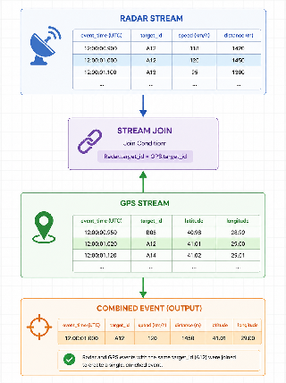
Why Stream-Stream Joins are Challenging?
Unlike traditional database joins, streaming joins must operate on continuously arriving data.
Several challenges exist:
- Events may arrive at different times.
- Network delays may occur.
- Sensors may report at different frequencies.
- Some records may arrive late.
Because of these challenges, stream-stream joins are commonly used together with watermarks. Watermarks allow Spark to wait briefly for delayed events before deciding whether a join can be performed.
Example in PySpark
The following simplified example demonstrates a stream-stream join:
radar_stream.join(
gps\_stream,
radar\_stream.target\_id \== gps\_stream.target\_id
)
This operation combines radar records and GPS records whenever both streams contain the same target identifier.
Benefits of Stream-Stream Joins
Stream-stream joins provide several advantages:
- Combine information from multiple sensors.
- Increase data completeness.
- Improve analytical accuracy.
- Support real-time decision making.
- Enable advanced data fusion techniques.
Without stream-stream joins, each sensor stream would remain isolated, limiting the amount of information available to downstream systems.

4.2.Stream-Stream Joins in Dataforge
Within the DataForge architecture, stream-stream joins play a critical role in transforming independent sensor streams into unified datasets. Rather than analyzing radar, GPS, and telemetry information separately, DataForge can combine them into richer records that contain multiple perspectives of the same event.
This capability forms the foundation for Data Fusion, which is discussed in the next section.

4.3.Sensor Fusion in DataForge
One of the primary objectives of the DataForge platform is to transform independent sensor streams into a unified and more informative representation of real-world events. This process is known as Sensor Fusion, or Data Fusion.
In many real-world environments, no single sensor can provide a complete picture of a situation. Different sensors observe different aspects of the same event, and each sensor has its own strengths and limitations. By combining information from multiple sources, a system can achieve a higher level of accuracy, reliability, and situational awareness.
Within DataForge, multiple streaming data sources may operate simultaneously, including:
- Radar Sensors
- GPS Sensors
- Telemetry Systems
- Environmental Sensors
- Each source contributes different information.
For example:
Radar Sensor
Target ID: A12
Speed: 120 km/h
Distance: 1450 m
GPS Sensor
Target ID: A12
Latitude: 41.01
Longitude: 29.00
Telemetry System
Target ID: A12
Status: Active
Battery Level: 87%
Individually, these records provide only partial information. However, after fusion, DataForge can create a single enriched event:
Target ID: A12
Speed: 120 km/h
Distance: 1450 m
Latitude: 41.01
Longitude: 29.00
Status: Active
Battery Level: 87%
This unified record provides a much more complete description of the target.
Why Sensor Fusion is Important
Sensor fusion provides several benefits:
- Improves data completeness.
- Increases analytical accuracy.
- Reduces uncertainty.
- Supports better decision making.
- Creates richer features for AI models.
- Enables real-time situational awareness.
Without fusion, analytics systems would need to interpret multiple independent streams separately. This often leads to incomplete or fragmented information.
Sensor Fusion Workflow in DataForge
A simplified DataForge fusion workflow is shown below:
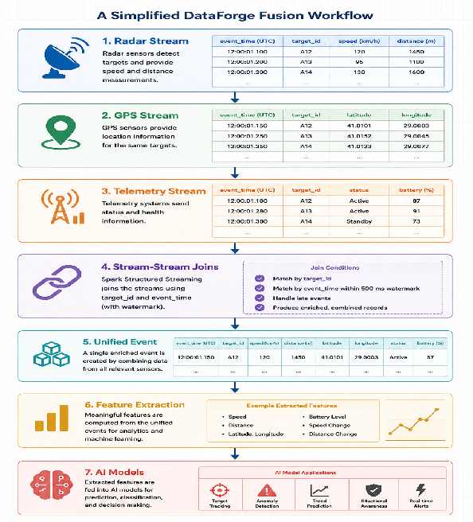
In this architecture, Spark Structured Streaming continuously receives events from Kafka topics and combines related records using stream-stream joins. The resulting fused events are then passed to downstream analytics and machine learning systems.
Sensor Fusion and AI
Sensor fusion plays a critical role in preparing data for artificial intelligence systems.
AI models generally perform better when they receive complete and enriched information rather than isolated sensor readings.
For example:
Radar Only:
Speed = 120 km/h
versus
Radar + GPS + Telemetry:
Speed = 120 km/h
Location = (41.01, 29.00)
Status = Active
Battery = 87%
The second dataset provides significantly more context and allows AI models to make more informed decisions.

4.4.Sensor Fusion in DataForge
Within the DataForge architecture, sensor fusion serves as a bridge between raw streaming data and intelligent analytics. By combining multiple sensor streams into unified events, DataForge can create a more accurate representation of real-world conditions and provide higher-quality inputs for dashboards, analytics platforms, and AI-driven decision-making systems.
For this reason, sensor fusion is one of the most important capabilities of the DataForge platform and represents a core use case for stream-stream joins in Spark Structured Streaming.

4.5.The Reason Stream-Stream Joins are Required for Data Fusion
Data Fusion is one of the core objectives of the DataForge platform. The purpose of Data Fusion is to combine information from multiple sensor streams and create a more complete representation of real-world events. However, in a streaming environment, data from different sensors arrives continuously and independently. A mechanism is therefore required to match related events and merge them into a single unified record.
This mechanism is provided by stream-stream joins.
Without stream-stream joins, each sensor stream would remain isolated. Radar data, GPS data, and telemetry data would be processed separately, preventing DataForge from building a complete view of a target or situation.
The Problem Without Stream-Stream Join
Consider the following example.
Radar reports:
Target ID: A12
Speed: 120 km/h
Distance: 1450 m
GPS reports:
Target ID: A12
Latitude: 41.01
Longitude: 29.00
Telemetry reports:
Target ID: A12
Status: Active
Battery Level: 87%
If these streams are processed independently, three separate records exist:
- Radar Information
- GPS Information
- Telemetry Information
No system component knows that these records describe the same target.
As a result:
- Information remains fragmented.
- Analytics become less accurate.
- AI models receive incomplete data.
- Situational awareness is reduced.
The Solution: Stream-Stream Joins
Stream-stream joins allow Spark Structured Streaming to identify related events and merge them into a single enriched record.
Example:
Target ID: A12
Speed: 120 km/h
Distance: 1450 m
Latitude: 41.01
Longitude: 29.00
Status: Active
Battery Level: 87%
This fused event contains information from all available sensors and provides a significantly more complete picture of the observed target.
Matching Events Across Streams
To perform a stream-stream join, Spark requires matching conditions.
Typical matching fields include:
- Target ID
- Sensor ID
- Device ID
- Event Time
For DataForge, the most common approach is expected to be matching by:
Target ID
+
Event Time
This ensures that records describing the same object and occurring within the same time period can be fused together.
Stream-Stream Joins and Watermarks
In real-world systems, matching events rarely arrive at exactly the same moment.
Example:
Radar Event:
12:00:01.000
GPS Event:
12:00:01.250
Telemetry Event:
12:00:01.420
Although all three events describe the same target, they arrive at different times.
This is why DataForge combines:
Stream-Stream Join
+
500 ms Watermark
The watermark allows Spark to wait briefly for delayed events before executing the join operation.
Without a watermark:
- Radar Event arrives.
- Join executes immediately.
- GPS and Telemetry arrive later.
Fusion fails.
With a watermark:
- Radar Event arrives.
- Spark waits.
- GPS arrives.
- Telemetry arrives.
Fusion succeeds.
Benefits for DataForge
Using stream-stream joins within DataForge provides several important benefits:
- Enables real-time sensor fusion.
- Improves data completeness.
- Increases analytical accuracy.
- Supports richer AI features.
- Reduces uncertainty.
- Improves situational awareness.
- Creates a unified view of sensor observations.

4.6.Stream-Stream Joins in the DataForge Pipeline
A simplified view is shown below:
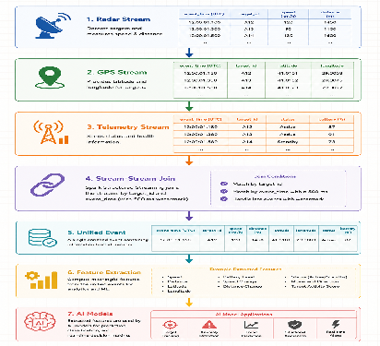
For these reasons, stream-stream joins are a fundamental requirement for Data Fusion within DataForge. They provide the mechanism that allows independent sensor streams to be transformed into unified events that can support advanced analytics, machine learning, and real-time decision-making.

5.Kafka and Spark Integration in DataForge

5.1 End-to-End Data Pipeline
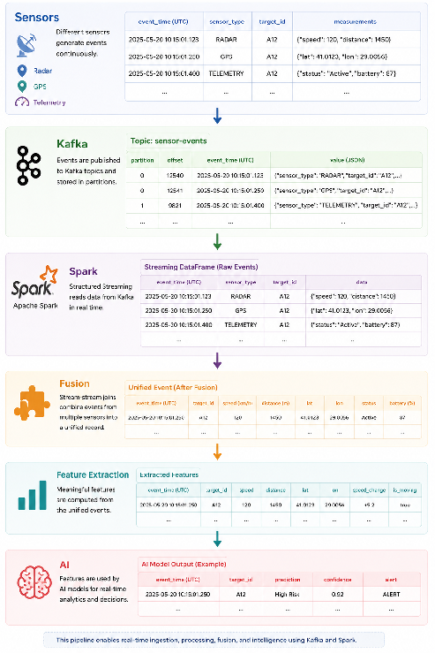
The following diagram illustrates the complete end-to-end data pipeline used within the DataForge architecture. The pipeline demonstrates how raw sensor data is collected, transported, processed, fused, and transformed into actionable intelligence for downstream analytics and AI systems.
The process begins with multiple sensor sources, including radar, GPS, and telemetry systems. These sensors continuously generate real-time events containing measurements such as speed, location, status information, and other operational data.
These events are then published to Apache Kafka topics, where they are stored and distributed through Kafka partitions. Kafka acts as the transportation layer of the architecture, providing reliable event delivery, scalability, and fault tolerance.
PySpark Structured Streaming consumes the events from Kafka in real time and converts them into structured DataFrames. Once the data has been ingested, Spark applies processing operations such as filtering, validation, aggregation, and event enrichment.
After processing, DataForge performs sensor fusion using stream-stream joins. Related events originating from different sensors are combined into a single unified event. This creates a more complete representation of the observed target by integrating measurements from multiple sources.
The fused events then pass through a feature extraction stage. During this stage, meaningful features such as speed changes, movement patterns, distance metrics, and status indicators are generated. These features provide valuable inputs for downstream analytics and machine learning models.
Finally, the extracted features are delivered to AI models, where they can be used for prediction, anomaly detection, classification, situational awareness, and real-time decision support. This complete pipeline enables DataForge to transform raw streaming sensor data into actionable intelligence while maintaining low latency and supporting real-time analytics.

5.2.Data Flow Example
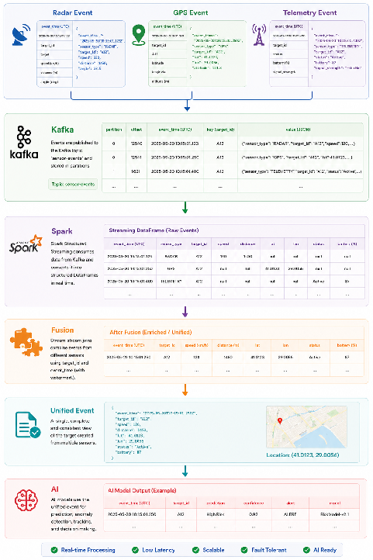
The following example demonstrates how data flows through the DataForge streaming architecture from initial sensor generation to AI-driven decision making. The diagram illustrates a typical scenario in which multiple sensors observe the same target and produce different pieces of information that are later combined into a unified event.
The process begins with three independent sensor sources. A radar sensor generates target tracking information such as speed, distance, and angle measurements. A GPS sensor provides geographic coordinates including latitude, longitude, and altitude. At the same time, a telemetry system reports operational data such as status information, battery level, and signal strength.
Each sensor publishes its events to Apache Kafka, where the records are stored in Kafka topics and distributed across partitions. Kafka serves as the central messaging layer that ensures reliable event transportation between producers and consumers.
PySpark Structured Streaming continuously consumes these events from Kafka and converts the raw JSON messages into structured DataFrames. At this stage, the records remain separate because each sensor only contributes a subset of the available information.
The next stage is Data Fusion. Using stream-stream joins and event-time matching, Spark combines related records that share the same target identifier and fall within the configured watermark interval. In the example shown, the radar, GPS, and telemetry records for target A12 are merged into a single enriched event.
The resulting unified event contains all relevant information about the target, including its speed, distance, location, operational status, and battery level. This provides a much more complete representation of the observed object than any individual sensor could provide on its own.
After fusion, DataForge performs feature extraction. Additional attributes such as speed changes, movement patterns, distance variations, and activity indicators can be calculated from the unified event. These derived features provide valuable inputs for downstream analytics and machine learning applications.
Finally, the processed features are supplied to AI models. These models can perform tasks such as anomaly detection, risk assessment, target tracking, classification, trend prediction, and real-time decision support. In the example shown, the AI model produces a prediction with an associated confidence score and alert status.
This example demonstrates how DataForge transforms raw streaming sensor data into actionable intelligence through a scalable pipeline built on Apache Kafka, PySpark Structured Streaming, Data Fusion, and AI-driven analytics.

5.3 Benefits for Real-Time Analytics and AI Models
The integration of Apache Kafka and PySpark Structured Streaming provides several important advantages for DataForge. By enabling continuous data ingestion, processing, and fusion, the platform can support both real-time analytics and AI-driven decision-making.
Real-Time Processing
Kafka and Spark allow DataForge to process sensor events as they arrive rather than waiting for large batches of data. This enables near real-time monitoring and rapid response to changing conditions.
Better Accuracy
By combining multiple sensor streams through Data Fusion, DataForge can create a more complete representation of observed targets and events. This reduces uncertainty and improves the accuracy of analytics results.
Better AI Features
Feature extraction performed on fused sensor data generates richer and more informative inputs for machine learning models. AI systems can use these features to make more reliable predictions and classifications.
Reduced Latency
Structured Streaming processes incoming events continuously, while Kafka efficiently transports data between system components. Together, they minimize the delay between data generation and analysis.
Improved Situational Awareness
By integrating information from radar, GPS, telemetry, and other sensor sources, DataForge can provide a unified operational view of the environment. This allows users and AI systems to make more informed decisions based on real-time information.
Summary
The combination of Kafka, Spark Structured Streaming, and Data Fusion enables DataForge to transform raw sensor streams into actionable intelligence. These capabilities support scalable real-time analytics, efficient feature generation, and high-quality AI-driven decision making.

6.Pyspark Structured Streaming Example
This section demonstrates a simple PySpark Structured Streaming application that consumes events from an Apache Kafka topic, filters incoming records, and writes the results to the console. The example represents a simplified version of the processing workflow that may be used within the DataForge architecture.

6.1.Kafka Source Configuration
The first step is creating a Spark session and configuring Kafka as the streaming source.
from pyspark.sql import SparkSession
spark = SparkSession.builder \
.appName("DataForgeStreaming") \\
.getOrCreate()
kafka_stream = spark.readStream \
.format("kafka") \\
.option("kafka.bootstrap.servers", "localhost:9092") \\
.option("subscribe", "sensor-events") \\
.load()
In this configuration:
- localhost:9092 specifies the Kafka broker.
- sensor-events is the Kafka topic being monitored.
- Spark continuously listens for new incoming events.

6.2.Event Filtering Example
Kafka stores message values as binary data. Therefore, the event payload must first be converted into a readable format before filtering can be applied.
The following example filters events based on a simple condition. Only records containing the keyword RADAR are allowed to pass through the pipeline.
from pyspark.sql.functions import col
events = kafka_stream.selectExpr(
"CAST(value AS STRING) as event"
)
filtered_events = events.filter(
col("event").contains("RADAR")
)
Example incoming events:
- RADAR,target=A12,speed=120
- GPS,target=A12,lat=41.0123
- TELEMETRY,target=A12,status=Active
- RADAR,target=A13,speed=95
Output after filtering:
- RADAR,target=A12,speed=120
- RADAR,target=A13,speed=95
Only radar events continue through the processing pipeline.

6.3.Processing and Output
After filtering, Spark can write the results to an output sink. For demonstration purposes, the console sink is used.
query = filtered_events.writeStream \
.outputMode("append") \\
.format("console") \\
.start()
query.awaitTermination()
When new radar events arrive in Kafka, Spark immediately displays them in the console.
Example output:
----------------------------------
Batch: 0
----------------------------------
RADAR,target=A12,speed=120
RADAR,target=A13,speed=95
This example demonstrates the core concepts of a real-time streaming application:
- Reading data from Kafka.
- Consuming events continuously.
- Filtering records based on business rules.
- Processing data in real time.
- Delivering results to an output sink.
Although simplified, this workflow represents the foundation of the DataForge streaming architecture. More advanced implementations may include JSON parsing, watermarks, window aggregations, stream-stream joins, data fusion, feature extraction, and AI model integration.

7.Key Learnings
The study of Apache Kafka and PySpark Structured Streaming provided several important insights into the design of real-time data processing systems. The following key learnings summarize the most significant concepts explored throughout this document.
Kafka as a Real-Time Data Transportation Layer
Apache Kafka serves as a scalable and reliable event streaming platform that decouples data producers from data consumers. By organizing events into topics and partitions, Kafka enables efficient transportation of high-volume sensor data while supporting fault tolerance and scalability.
Consumer Groups Enable Scalability
Consumer groups allow multiple consumers to process data in parallel. This improves throughput, provides load balancing, and enables DataForge to scale horizontally as data volumes increase.
Spark Structured Streaming Enables Continuous Processing
PySpark Structured Streaming provides a framework for processing data as it arrives. Instead of waiting for batch jobs, Spark continuously consumes events from Kafka and performs real-time transformations and analytics.
Event Filtering Improves Data Quality
Filtering is an important early-stage processing step. By removing invalid, corrupted, or low-priority events, Spark reduces unnecessary processing and improves the overall quality of downstream analytics.
Window Processing Supports Real-Time Analytics
Window-based processing allows Spark to aggregate events over specific time intervals. This makes it possible to calculate meaningful statistics such as averages, counts, and trends from continuous sensor streams.
Watermarks Handle Late Events
Watermarks help Spark process delayed events correctly while maintaining low latency. For DataForge, a 500-millisecond watermark provides a balance between processing speed and analytical accuracy.
Stream-Stream Joins Enable Data Fusion
Stream-stream joins allow Spark to combine related records from multiple sensor streams. This capability is essential for Data Fusion because it transforms isolated sensor readings into unified and enriched events.
Sensor Fusion Improves Situational Awareness
Combining radar, GPS, telemetry, and other sensor sources provides a more complete understanding of observed targets. This improves analytical accuracy and supports more effective decision-making.
Feature Extraction Creates Valuable AI Inputs
Feature extraction transforms fused sensor data into meaningful attributes that can be used by machine learning models. Richer features generally lead to better predictive performance and more reliable AI systems.
Kafka and Spark Form the Foundation of DataForge
Together, Apache Kafka and PySpark Structured Streaming create a complete real-time data pipeline capable of ingesting, processing, fusing, and analyzing sensor data. These technologies form the core infrastructure required for future DataForge implementations.

8.Conclusion
This document explored the fundamental concepts of Apache Kafka and PySpark Structured Streaming and examined their role within the DataForge architecture. As modern systems increasingly rely on real-time data processing, technologies capable of handling continuous event streams have become essential components of scalable analytics platforms.
Apache Kafka provides a reliable and fault-tolerant mechanism for transporting large volumes of sensor and telemetry data. Through the use of topics, partitions, and consumer groups, Kafka enables scalable event streaming while ensuring that data can be delivered efficiently to downstream systems. Within DataForge, Kafka serves as the central transportation layer that connects data producers and consumers.
PySpark Structured Streaming complements Kafka by providing real-time processing capabilities. By continuously consuming events from Kafka topics, Spark can perform filtering, aggregation, window processing, watermark management, and stream-stream joins. These operations transform raw sensor data into structured and meaningful information suitable for analytics and machine learning applications.
A particularly important concept discussed throughout this document is Data Fusion. By combining information from multiple sensor streams such as radar, GPS, and telemetry systems, DataForge can generate unified events that provide a more complete and accurate representation of real-world situations. Stream-stream joins and watermarks play a critical role in enabling this process while maintaining low latency and high analytical accuracy.
The practical PySpark example demonstrated how Kafka and Spark can be integrated to build a simple real-time processing pipeline. Although the example was intentionally simplified, it illustrates the core principles that will be expanded upon in future DataForge implementations.
Overall, Kafka and PySpark Structured Streaming provide the foundation required for building a scalable real-time data platform. Together, they enable DataForge to collect, transport, process, fuse, and analyze streaming sensor data efficiently. The concepts covered in these learning notes establish a strong basis for future development work involving advanced analytics, Data Fusion, feature extraction, and AI-driven decision-making systems.
In conclusion, the combination of Apache Kafka and PySpark Structured Streaming offers a powerful and flexible architecture for real-time data processing. These technologies will play a central role in supporting the long-term goals of DataForge and its future implementation phases.

